NOTICE OF PROPOSAL
LANCASHIRE COUNTY COUNCIL
(A59 LIVERPOOL ROAD, PENWORTHAM, SOUTH RIBBLE BOROUGH)
(INTRODUCTION OF BUS STOP CLEARWAY)

NOTICE IS HEREBY GIVEN that Lancashire County Council propose to introduce a Bus Stop Clearway at any time (the effect of which will be to prohibit the stopping of vehicles) in the following lengths of road:
- A59 Liverpool Road, Penwortham, the north west side, from a point 70 metres south west of its junction with the centreline of Howick Park Avenue, for a distance of 29 metres in a south westerly direction.
- A59 Liverpool Road, Penwortham, the south east side, from a point 72.5 metres south west of its junction with the centreline of Brandwood, for a distance of 17 metres in a south westerly direction.
- A59 Liverpool Road, Penwortham, the north west side, from a point 28.5 metres south west of its junction with the centreline of Blashaw Lane, for a distance of 29 metres in a south westerly direction.
- A59 Liverpool Road, Penwortham, the south east side, from a point 35.5 metres south west of its junction with the centreline of Carleton Drive, for a distance of 29 metres in a south westerly direction.

Statement of Reasons
The purpose of this proposal is to introduce four Bus Stop Clearways to improve facilities for users of the 2 and 2A bus route from Preston to Hutton and the 2 and 2A bus route from Hutton to Preston. The markings will also enhance cyclist awareness of potential conflicts with stationary buses.

Any representations or objections (specifying the grounds on which they are made) relating to the proposal must be made in writing and should be sent to Legal and Democratic Services, Lancashire County Council, PO Box 78 County Hall, Preston PR1 8XJor by e-mail to tro-consultation@lancashire.gov.uk quoting ref: LSG4/894.10779/AFR before the 05 February 2020

Laura Sales, Director of Corporate Services
08 January 2020

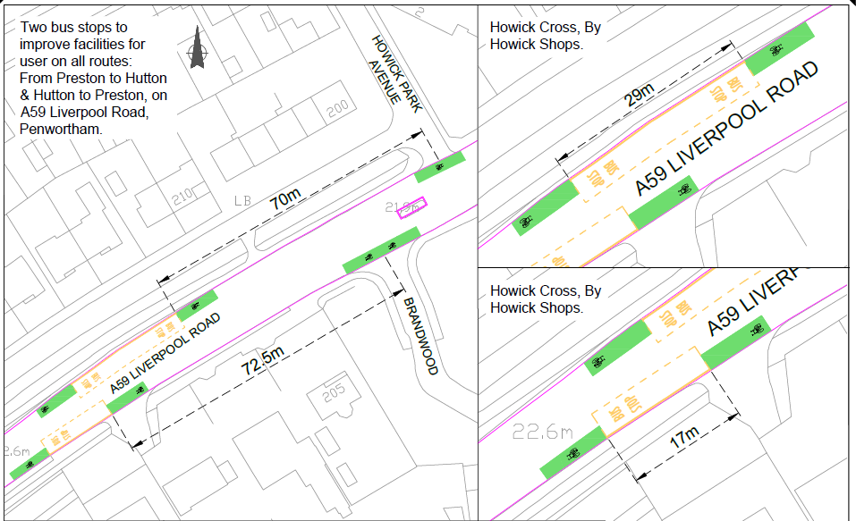

Based upon Ordnance Survey data with the permission of the Controller of Her Majesty's Stationery Office Crown Copyright Licence No 100023520 Unauthorised reproduction infringes Crown Copyright and may lead to prosecution or civil proceedings.
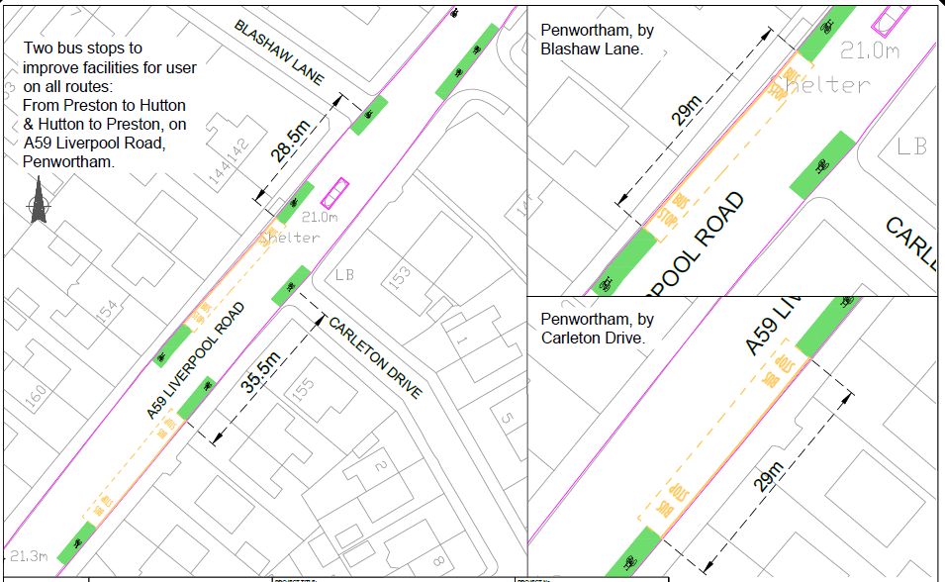
Based upon Ordnance Survey data with the permission of the Controller of Her Majesty's Stationery Office Crown Copyright Licence No 100023520 Unauthorised reproduction infringes Crown Copyright and may lead to prosecution or civil proceedings.

